**Experiment 11 Date:** 04/04/2023

**Aim:**

Familiarization of Linux Commands

**Course Outcome(CO4):**

Write shell scripts required for system administration

**Procedure:**

1. Shell script to demonstrate Relational operators (equal to, not equal to, greater than, less than, greater than or equal to, less than or equal to) by taking user input

vi filename.sh

Press ‘i’ to INSERT

#!/bin/bash

read -p "Enter the First number: " num1

read -p "Enter the Second number: " num2

if(( $num1 == $num2 ))

then

echo "== : $num1 is equal to $num2"

else

echo "== : $num1 is not equal to $num2"

fi

if(( $num1 != $num2 ))

then

echo "!= : $num1 is not equal to $num2"

else

echo "!= : $num1 is equal to $num2"

fi

if(( $num1 > $num2 ))

then

echo "> : $num1 is greater than $num2"

else

echo "> : $num1 is not greater than $num1"

fi

if(( $num1 < $num2 ))

then

echo "< : $num1 is less than $num2"

else

echo "< : $num1 is not less than $num2"

fi

if(( $num1 >= $num2 ))

then

echo ">= : $num1 is greater than or equal to $num2"

else

echo ">= : $num1 is not greater than or equal to $num2"

fi

if(( $num1 <= $num2 ))

then

echo "<= : $num1 is less than or equal to $num2"

else

echo "<= : $num1 is not less than or equal to $num2"

fi

Press ‘Esc’ to end INSERT

:wq!

chmod +x filename.sh

./filename.sh

Output:

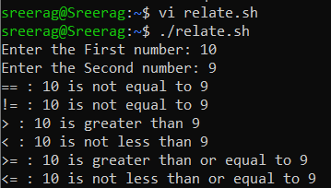

1. Shell script to demonstrate Relational operators (equal to, not equal to, greater than, less than, greater than or equal to, less than or equal to)

vi filename.sh

Press ‘i’ to INSERT

#!/bin/bash

num1=54

num2=20

if [ $num1 -eq $num2 ]

then

echo "-eq : $num1 is equal to $num2"

else

echo "-eq: $num1 is not equal to $num2"

fi

if [ $num1 -ne $num2 ]

then

echo "-ne: $num1 is not equal to $num2"

else

echo "-ne: $num1 is equal to $num2"

fi

if [ $num1 -gt $num2 ]

then

echo "-gt: $num1 is greater than $num2"

else

echo "-gt: $num1 is not greater than $num1"

fi

if [ $num1 -lt $num2 ]

then

echo "-lt: $num1 is less than $num2"

else

echo "-lt: $num1 is not less than $num2"

fi

if [ $num1 -ge $num2 ]

then

echo "-ge: $num1 is greater than or equal to $num2"

else

echo "-ge: $num1 is not greater than or equal to $num2"

fi

if [ $num1 -le $num2 ]

then

echo "-le: $num1 is less than or equal to $num2"

else

echo "-le: $num1 is not less than or equal to $num2"

fi

Press ‘Esc’ to end INSERT

:wq!

chmod +x filename.sh

./filename.sh

Output:

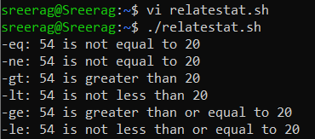

1. Shell script to demonstrate Logical operators (AND, OR, NOT) by taking user input

vi filename.sh

Press ‘i’ to INSERT

#!/bin/bash

read -p "Enter the First Boolean: " b1

read -p "Enter the Second Boolean: " b2

if(($b1 == "true" & $b2 == "true" ))

then

echo Both are true

else

echo Both are not true

fi

if(($b1 == "true" || $b2 == "true" ))

then

echo Atleast one of them is true

else

echo None of them are true

fi

if(( ! $b1 == "true" ))

then

echo "b1" was initially false

else

echo "b1" was initially true

fi

Press ‘Esc’ to end INSERT

:wq!

chmod +x filename.sh

./filename.sh

Output:

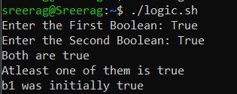

1. Write a shell script to check if a number is even or odd.

vi filename.sh

Press ‘i’ to INSERT

#!/bin/bash

read -p "Enter a Number: " num1

if(( $num1 == 0 ))

then

echo "$num1 is neither odd nor even number"

elif(( $num1 % 2 == 0 ))

then

echo "$num1 is an even number"

else

echo "$num1 is a odd number"

fi

Press ‘Esc’ to end INSERT

:wq!

chmod +x filename.sh

./filename.sh

Output:

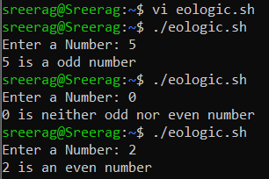

1. Write a shell script to check whether a number is positive or negative

vi filename.sh

Press ‘i’ to INSERT

#!/bin/bash

read -p "Enter a Number: " num1

if(( $num1 > 0 ))

then

echo "$num1 is a positive number"

elif(( $num1 < 0 ))

then

echo "$num1 is a negative number"

else

echo "$num1 is zero"

fi

Press ‘Esc’ to end INSERT

:wq!

chmod +x filename.sh

./filename.sh

Output:

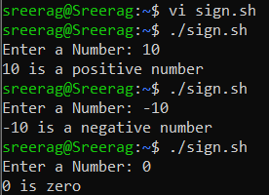

1. Write a shell script to find the greatest of two numbers

vi filename.sh

Press ‘i’ to INSERT

#!/bin/bash

read -p "Enter the first number: " num1

read -p "Enter the second number: " num2

if(( $num1 > $num2 ))

then

echo "$num1 is greater than $num2"

else

echo "$num2 is greater than $num1"

fi

Press ‘Esc’ to end INSERT

:wq!

chmod +x filename.sh

./filename.sh

Output:

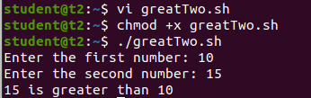

1. Write a shell script to find the greatest of three numbers

vi filename.sh

Press ‘i’ to INSERT

#!/bin/bash

read -p "Enter the first number: " num1

read -p "Enter the second number: " num2

read -p "Enter the third number: " num3

if(( $num1 > $num2 & $num1 > $num3 ))

then

echo "$num1 is the greatest of the three"

elif(( $num2 > $num3 ))

then

echo "$num2 is the greatest of the three"

else

echo "$num3 is the greatest of the three"

fi

Press ‘Esc’ to end INSERT

:wq!

chmod +x filename.sh

./filename.sh

Output:

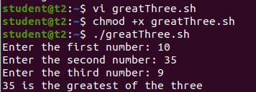

**Result:**

Output displayed successfully and CO4 was obtained.